Individual Assignment
Name: Nimesh Chandupa Peiris
StudentID: 152212239
Group: C1

- Class Diagram
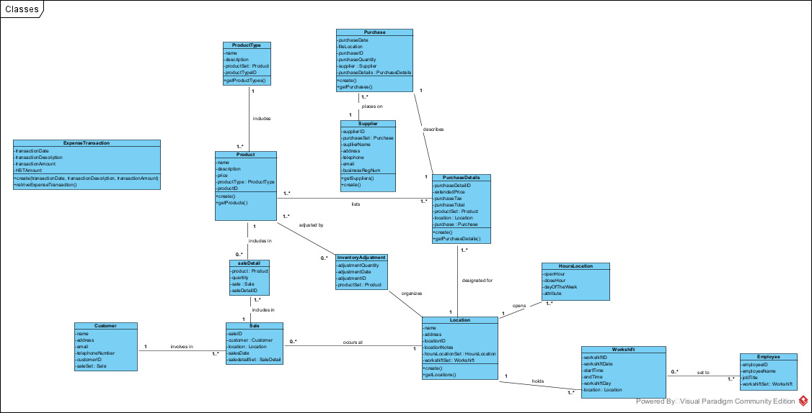

Functionality I worked with only relates to Supplier class
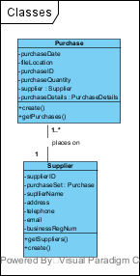

- Sequence diagram

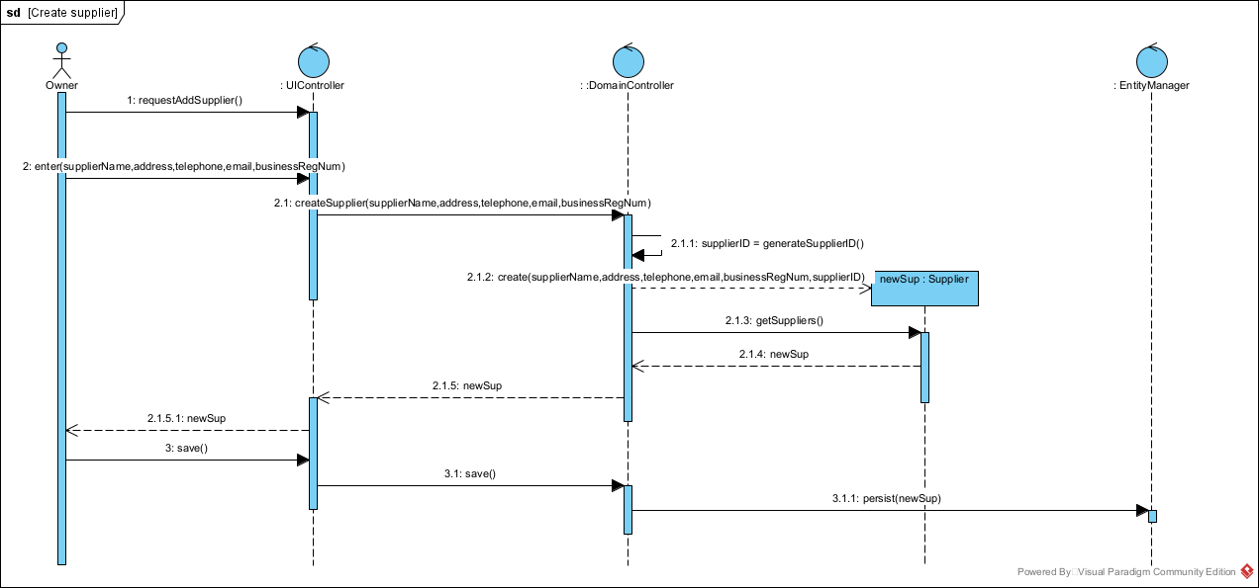

- Mockup

Add Supplier

Supplier ID: XXXXXXXXX
Supplier Name: _________________________
Supplier Business Registration Num: _________________________
Telephone Number: _______________________
Email: __________________________
Address: __________________________________

- User story
As the owner of this business, I would like to save contact and business information of my suppliers.

- Brief report
As the GameStart company expanding and need to have more and more products, they need to rely on several suppliers. Therefore it is essential to do supplier management. So, the owner of the company should be able to create/add new suppliers for the company by validating all the necessary information that is needed to assign a supplier to the company’s system.

